TASK 4
Data Storytelling & Stakeholder Communication
iNeuBytes VIIP — Data Analyst Internship

Intern Name | Devpal Singh Anand
Regd No | INBT019627
Course ID | DAINB20626
Education | BCA · MCA Cyber Security
Dataset | Olist Brazilian E-Commerce (olist.db)

1. Executive Summary
Problem: Understand revenue drivers, customer behavior, logistics performance.
Findings:
- R$ 13.6M revenue, 96,478 orders
- SP = 38% of revenue
- 91.9% on-time; faster delivery = better reviews
- 3.1% repeat rate — one-time-purchase driven
Recommendation: Diversify marketing, prioritize delivery, build retention.
2. KPI Scorecard
KPI | Value | Status
Total Revenue | R$ 13,591,644 | ✓
Total Orders | 96,478 | ✓
AOV | R$ 137.75 | ✓
Avg Review | 4.09/5.0 | ✓
On-Time | 91.89% | ✓
Repeat Rate | 3.12% | ⚠

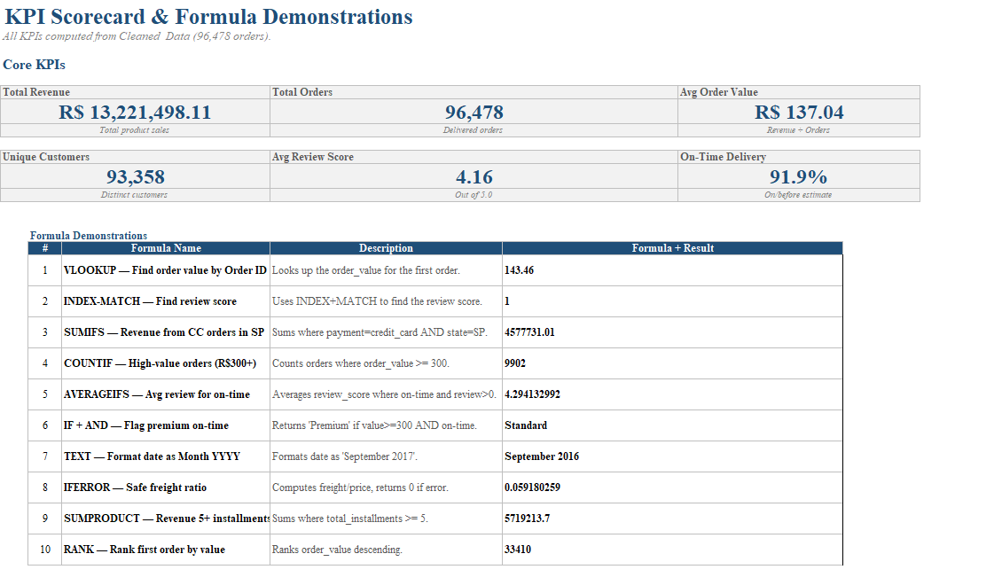
📸 KPI Scorecard

3. Three Key Insights
3.1 Category Concentration
Context: Top 10 categories dominate revenue — health_beauty (R$1.26M) and watches_gifts (R$1.21M) lead, with the top 25% of product categories generating 79.3% of total revenue (Pareto pattern).
Insight: Revenue is concentrated in a handful of categories rather than spread evenly across the catalog.
Implication: Heavy reliance on a few categories of products means demand shocks or stockouts in health_beauty or watches_gifts could disproportionately hurt revenue.
Recommendation: Expand marketing and inventory depth in mid-performing categories (bed_bath_table, sports_leisure, computers_accessories) to reduce dependency on the top few.
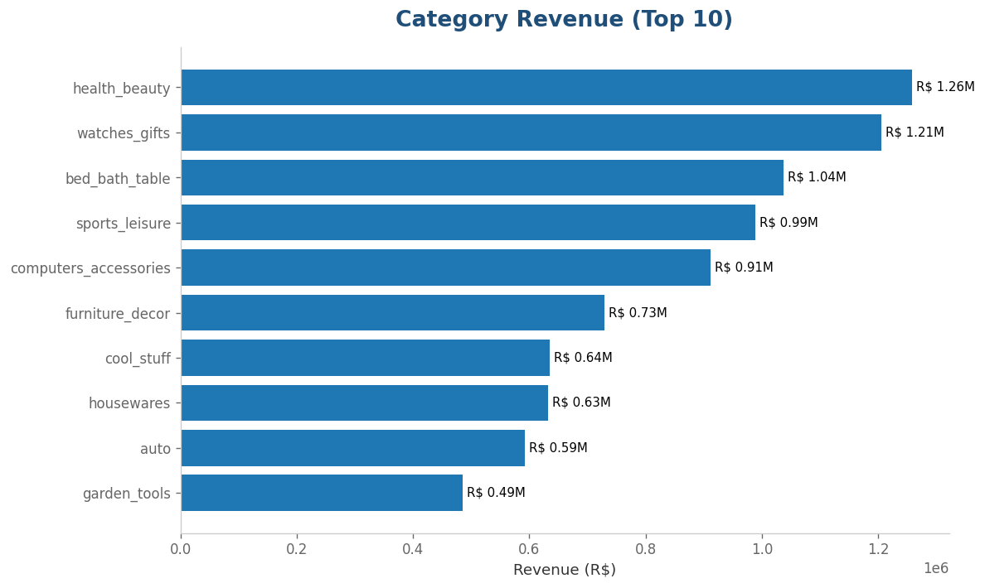
📸 Revenue by Category

3.2 Delivery Speed Drives Reviews
Context: 91.9% on-time, 12.6 day avg.
Insight: 0-7 days = 4.42★, 22+ days = 3.12★
Implication: Longer delivery times are strongly associated with lower review scores
Recommendation: Keep under 14 days.
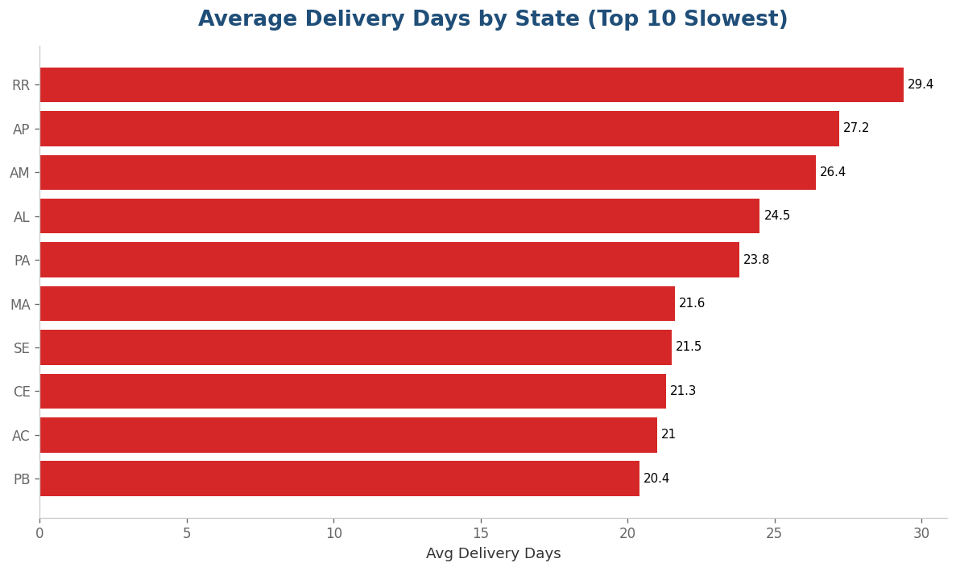
📸 Delivery by State

3.3 Payment Behavior
Context: Credit card = 78.3%.
Insight: 33.15% pay in full, 16.16% use 2 installments.
Implication: Removing installments may hurt conversion, since it appears to be an important part of the payment system.
Recommendation: Maintain flexible options.
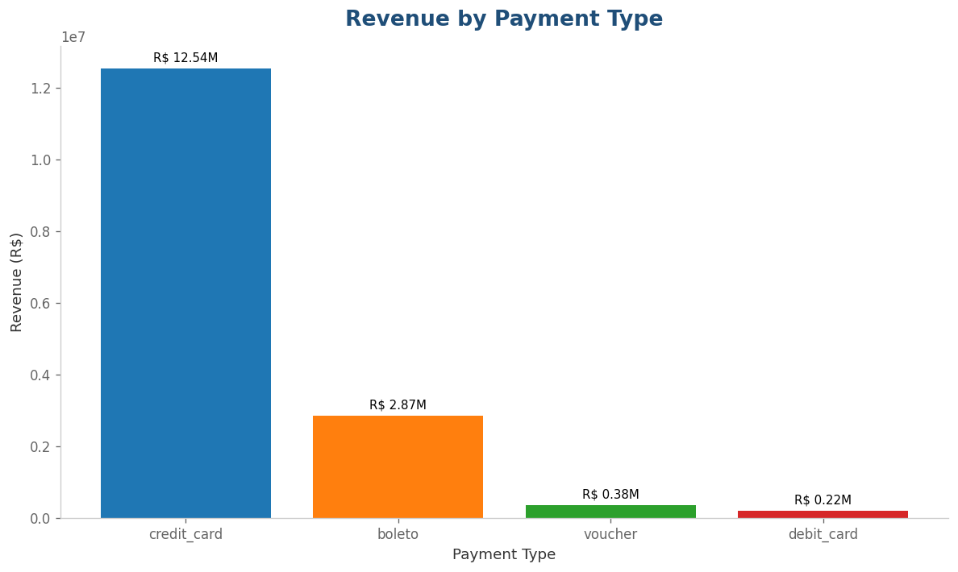
📸 Payment Type

4. Before/After Chart Improvements
4.1 Excel: -
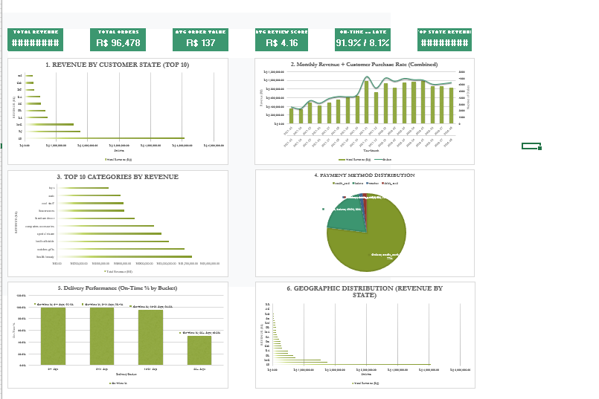
📸 BEFORE
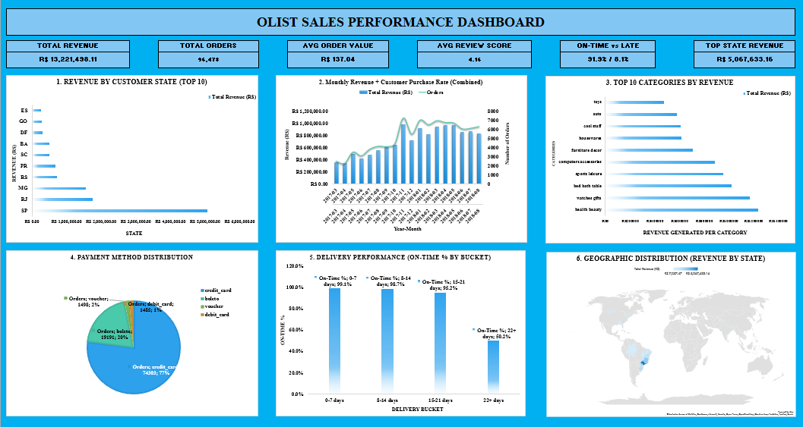
📸 AFTER
4.2 Power BI: -
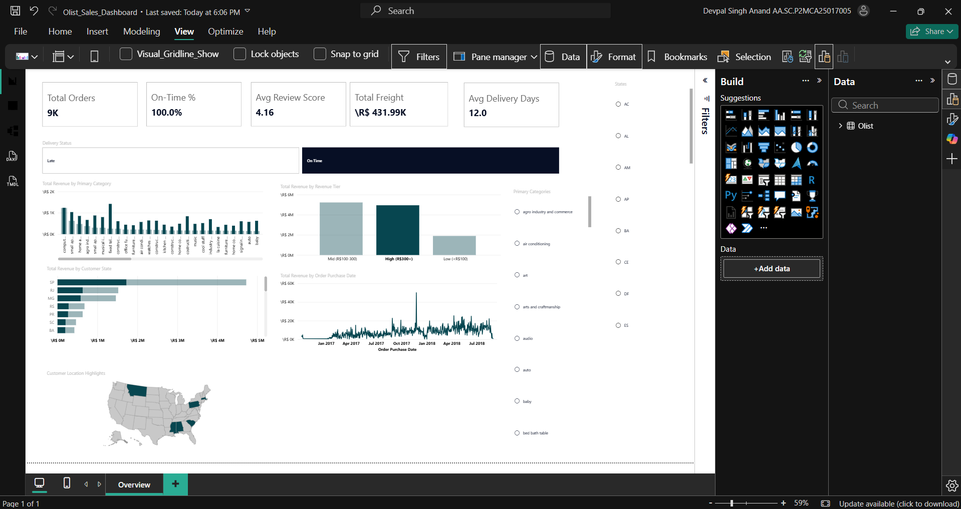
📸 BEFORE
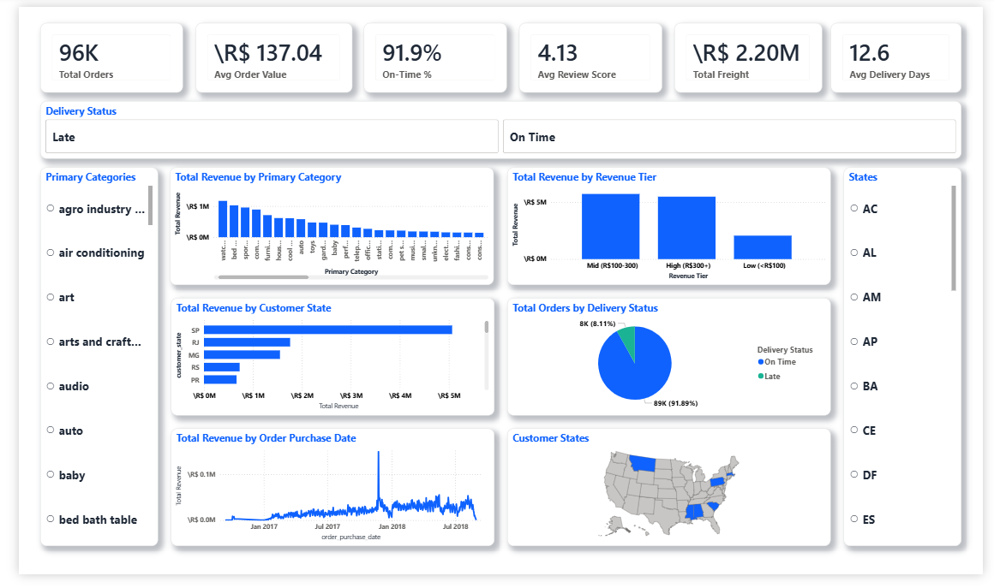
📸 AFTER

4.3 Tableau: -
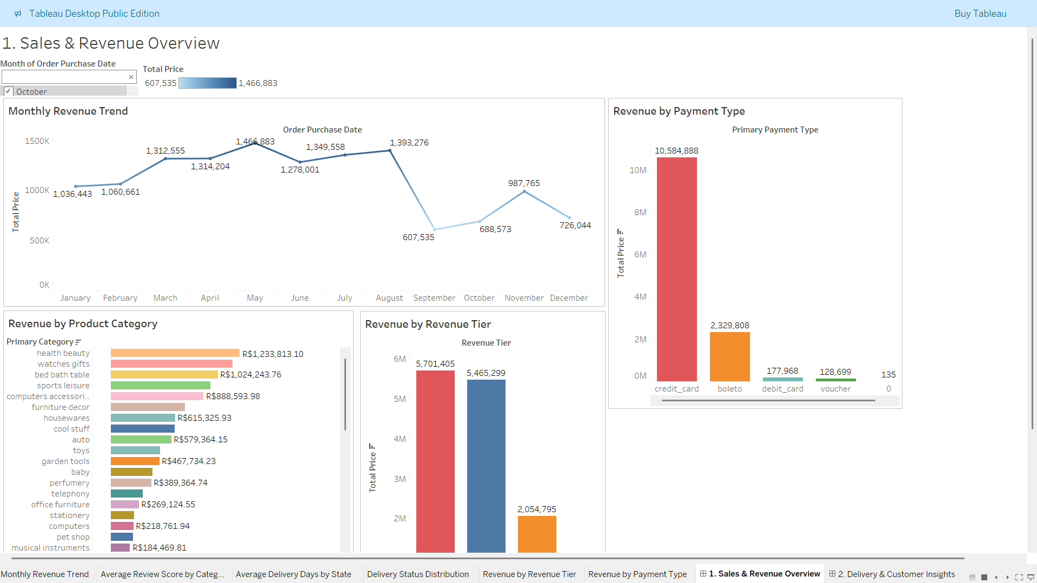
📸 Dashboard 1
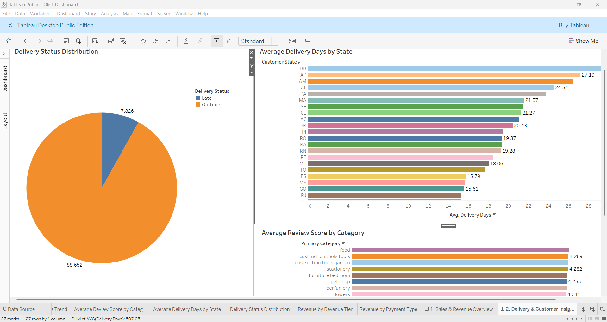
📸 Dashboard 2

5. Recommendations
# | Recommendation | Rationale
1 | Diversify geography | Reduce SP’s share from 38% to 30%
2 | Fast delivery | Aim for under 14 days to support 4.0+ reviews
3 | Retention programs | 3.1% repeat rate indicates a strong opportunity to improve customer retention
4 | Maintain installments | Credit cards account for roughly 77-81% of orders and revenue
5 | Top 25% product categories | Generate around 79% of revenue

